Ozobots
I attended the Ozobot (and learned that it is OH-zo-bot, not oz-o-bot!) session at ASTE, led by Mrs. Leola Rutherford, Girdwood Elementary school.
What is an Ozobot? It is a small, programmable robot about the size of a ping pong ball. It can move, flash colored lights and make noises. Meet Ozobot Evo here: https://youtu.be/mRDb7_dIxIA
Mrs. Rutherford and her student set up stations to demonstrate some of the different types of activities you can do with Ozobots. I was particularly intrigued with the student designed challenges and ways to solve them. Robots can be the problem solvers of the future. However, they need people with creative problem solving mines to make them work.
Here in Alaska, robots are part of the solution to make mining operations safer. Several examples can be found in “The Advances of Technology & Methods of Future Mining Operations”, (2018, February 2, https://alaskastructures.com/mining/advances-in-mining-technology-methods/)
In South Africa, two men built a land mine detection robot to help save people from explosives left over from time of war. “Engineer Profile: Robot Land Mine Detector / Design Squad” (2017, February 27, https://www.youtube.com/watch?v=ZyrnIm3MAaw)
And, in the classroom, the video “Authentic Problem Solving with Robots” (note: English subtitles) shows students creating robots to solve a variety of problems affecting people in their area. (2017, November 22, https://www.youtube.com/watch?v=AiT0OWq98Qo).
I love the idea of using Ozobot Evos as an entry point to sparking student interest in robotics. Coding, problem solving, creativity and fun (seriously, who can resist a mini robot that beeps like R2D2, spins in circles and can flash different colors?) are all part of Ozobot challenges.
Mrs. Rutherford’s students created the challenges for the robots to perform, including creating a maze, following static code to write someone’s name and the ‘hamster wheel’. The challenges that really caught my attention for high school students involved solving a real world environmental problem. One of them was Snow Removal and another was Ocean Clean-Up. Participants had the opportunity to choose from a wide variety of materials to turn their Ozobot Evo into a working machine (craft sticks, chenille stems, straws, condiment cups and more).
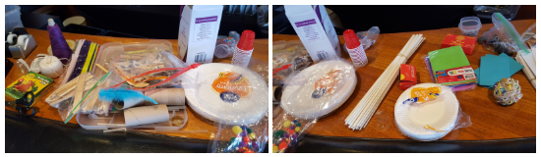
A VERY important tip is that you should NEVER attach anything to the Ozobot Evo itself, but attach the protective skin to the robot first.
In the Snow Plow Challenge, white pom poms were scattered and the Ozobot needed to move them to a ‘snow dump’ area. Living in Valdez, I’m familiar with the challenges of snow removal. Having students think about the design (you don’t want the snow to fall off the edges), as well as the strategy for moving the most snow in the least amount of time, is a real world challenge that our street maintenance workers face regularly.
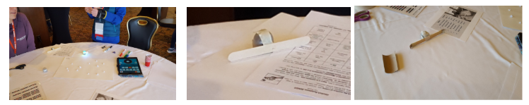
In the Ocean Clean-Up Challenge, a variety of materials were placed in the ocean (blue paper) and the Ozobot had to move them to a catch basin (turquoise paper) area.
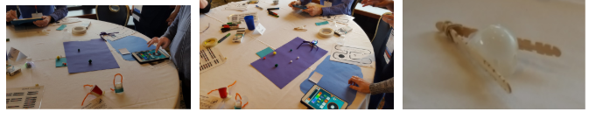
After creating and testing the different designs, participants could revise to adjust what did and didn’t work. For example, the spider looking device in the center photo had a problem with pompoms slipping under the chenille stems before they ended up in the catch basin area.

